UNIT IV - CORROSION AND ITS CONTROL
PART – A
1. Define corrosion. List the factors affecting corrosion.
Corrosion
Any process of destruction and resulting loss of a solid metallic material is called corrosion.
This happened through unwanted chemical or electrochemical attack by its environment, at its surface.
Example: Rusting of iron
Factors affecting corrosion
- presence of water, electrolytes and dissolved oxygen
- purity of metal and temperature

2. Define Pilling Bedworth Rule. (Jan 13, 14, 15, May 15)
Pilling Bedworth Rule
(a) An oxide layer is porous and non-protective, if volume of metal oxide formed is less than volume of metal from which it is formed. V_{MO} ≤ V_{M}
Example: Alkali metals and alkaline earth metals.
(b) An oxide layer is non-porous and protective, if volume of metal oxide formed is at least as great as volume of metal from which it is formed. V_{MO} ≥ V_{M}
Example: Al and Cu.

3. Differentiate Chemical and Electrochemical corrosion. (May 19)
Dry (or) Chemical corrosion | Wet (or) Electrochemical corrosion
(i) Occurs in dry state  (ii) Chemical attack of metal by environment  (iii) Corrosion products accumulate in same spot where corrosion occurs  (iv) Example: Formation of scale on iron. | Occurs in presence of moisture or electrolyte  Setting large number of tiny galvanic cells  Corrosion occurs at anode while products gather at cathode  Example: Rusting of iron in moist atmosphere.

4. Give four examples for galvanic corrosion.
Galvanic corrosion - Examples
(i) Steel screws in a brass marine hardware
(ii) Lead-antimony solder around copper wire
(iii) A steel propeller shaft in bronze bearing
(iv) Steel pipe connected to copper plumbing.

5. Give four examples for concentration cell corrosion.
Concentration cell corrosion - Examples
- Iron corrodes under drops of water
- Corrosion in steel water tanks in cracks
- Corrosion in metals under block of wood
- Corrosion under piece of glass.

1
6. Distinguish between Galvanizing and Tinning. (May 14, Jan 15)
Galvanizing | Tinning
(i) Covering iron with a thin coat of Zinc metal  (ii) Zinc protects base metal sacrificially  (iii) Galvanized containers cannot be used for storing foodstuffs, as it forms poisonous compound. | Covering steel with a thin coat of Tin metal  Protects metal by higher corrosion resistance  Tin coated containers can be used for storing foodstuff, since tin with acid is non toxic.

7. Give the methods of treatment of metal surfaces before coating.
Treatment of metal surfaces
Metal surfaces are covered with impurities (rust & old paint) resulting porous, non-adherent coatings.
To get smooth and adherent coating, these substances should be removed by,
(i) Solvent cleaning, (ii) Acid pickling, (iii) Alkali cleaning and (iv) Mechanical cleaning

8. Brief about metal cladding. (Nov 10)
Metal cladding
In this process a dense layer of coating metal is bonded or sandwiched between two layers of coat metal and pressed between rollers.
Example: Corrosion-resisting metals like nickel, copper and their alloys are used.
Base metals are mild steel, aluminium and their alloys.
Application
In aircraft industry as alclad sheeting.
In this, a plate of duralumin is sandwiched between two layers of 99.5% pure aluminium.

9. Write briefly on anodizing. (May 11, 13, 14, Jan 15)
Anodizing
Oxidation of metal surfaces by electrolysis process is called anodizing.
These coating are produced on non ferrous metals by anodic oxidation in which base metal acts anode.
Example
Anodizing of aluminium
Application
(i) forms insulating coat for aluminium and protects zinc and chromium.
(ii) air craft parts and machine parts are protected by anodizing.

10. Distinguish between electroplating and anodizing. (Jan 13)
Electroplating | Anodizing
(i) Electrolytic process  (ii) Metal is made as cathode  (iii) Occurs at cathode and layer is not porous  Example: Copper plating over iron. | Electrical process  Metal is made as anode  Occurs at anode and layer is porous  Example: Oxide coating over aluminium.

2
11. Zinc is more readily corroded, when coupled with copper than with lead. Why? (May 14)
Zinc is corroded, when coupled with copper than with lead
Standard reduction potential values of given metals are,
Zn = – 0.76 V Pb = – 0.13 V Cu = + 0.34 V
The difference between zinc and copper is more when compared to lead. Hence zinc is more readily corroded, when coupled with copper than with lead.
12. Why impure metal corrodes faster than pure metal under identical conditions? (May 15, 19)
Impure metal corrodes faster than pure metal
Impurities in a metal cause heterogeneity.
It forms minute electrochemical cells at exposed parts and acts as anode.
Thus anodic parts of impure metal get corroded.

13. Why anodizing best suited for Aluminium? (Jan 14)
Anodizing is best suited for Aluminium
During anodizing, aluminium form non-porous, tightly adhering oxide film (Al₂O₃).
This on treatment with hot water changes porous alumina to monohydrate which occupies more volume and pores are sealed.
Thus this process stops further corrosion.

14. Steel pipe in large copper tank corrodes causing rapid destruction. Explain. (May 13)
Steel pipe in large copper tank corrodes causing rapid destruction
Steel is anodic with respect to copper.
When a steel pipe fitted in a large copper tank is exposed to atmosphere, galvanic corrosion starts and anodic metal, iron starts corroding.
Small steel pipe (anode) in a large copper tank (cathode) causes rapid and intense corrosion.

15. Corrosion occurs in steel pipe connected to copper plumbing. Explain. (Nov 11, May 13, Jan 15)
Corrosion occurs in steel pipe connected to copper plumbing
When steel pipe connected to copper plumbing is exposed to electrolyte, galvanic corrosion occurs.
Thus, iron forms anode and is attacked and corroded.
Whereas copper acting as cathode is protected.

3
PART - B
1. Explain various factors influencing corrosion. (May 11, 12, 13, 14, 15, 19, Jan 13, 15)

Factors influencing corrosion
(a) Nature of Metal
(i) Position in Galvanic Series
Greater the difference in electrochemical series, faster is the corrosion of anodic metal.
(ii) Overvoltage
Reduction in overvoltage of corroding metal accelerates corrosion rate.
(iii) Relative areas of anodic and cathodic parts
If anodic area is small, corrosion is more rapid, severe and highly localized.
(iv) Purity of metal
Extent of corrosion increases with increasing exposure and extent of impurities.
(v) Volatility of corrosion products
If corrosion product is volatile, it causes continuous corrosion. Example: MoO₃ is volatile.
(vi) Nature of surface film
If ratio of volume of metal oxide to metal is less, oxidation corrosion rate is high.
(vii) Passive character of metal
Passive metals (Al, Mg and Ni) exhibit corrosion resistance than expected from galvanic series.

(b) Nature of Environment
(i) Temperature
With increase in temperature, corrosion rate is enhanced.
(ii) Humidity
If humidity of air is high, corrosion rate of metal increases sharply.
(iii) Presence of impurities in atmosphere
In presence of industrial gases (SO₂ and HCl), acidity increases results in increase of corrosion.
(iv) Influence of pH
Generally acidic media are more corrosive than alkaline and neutral media.
(v) Formation of oxygen concentrated cell
With increase in supply of oxygen/air to moist-metal surface, corrosion is promoted.
(vi) Polarization of electrode
Corrosion rate is controlled by current flowing in circuit.

4
2. Explain mechanism in Wet or electrochemical corrosion. (May 12, 13, 14, 15, Jan 14, 15)
Wet corrosion
The process of destruction and consequent loss of solid metallic materials through electrochemical attack in presence of a conducting medium is called Wet corrosion.
Mechanism
Wet corrosion occurs due to the existence of separate anodic and cathodic parts between which the current flows through the conducting solution.
Reactions
At anode: M M^{n+} + n e – , dissolution of metallic ions with release of electrons takes place.
At cathode: Dissolved constituents in conducting medium accept electrons to form ions like OH–.
Depending on the nature of corrosive environment, cathode reactions are,
(a) Hydrogen evolution
This corrosion takes place when base metal is in contact with acidic solution.
Example: Corrosion of iron in industrial water containing HCl.
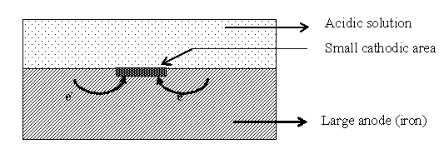
Diagram

Anode reaction: Fe Fe²⁺ + e – , dissolution of iron as ferrous ions with liberation of electrons.
Cathode reaction: H ⁺ + e – H_{2 ,} electrons react with acidic ion and liberate hydrogen gas.
In hydrogen evolution corrosion, anodes are very large areas and cathodes are small areas.
(b) Oxygen absorption
This corrosion takes place when base metal is in contact with neutral solution of electrolytes in presence of atmospheric oxygen.
Example: Rusting of iron in neutral solution of NaCl electrolyte in presence of atmospheric oxygen.
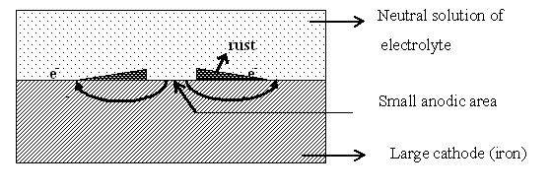
Diagram

Surface of iron is usually coated with a thin film of iron oxide. If this film develops cracks, tiny electrochemical cell is formed when it is immersed in a conducting medium containing dissolved oxygen.
Here, well coated part acts as cathode and the pores or cracks acts as anode.
At anode: Fe Fe²⁺ + e – , iron dissolves as ferrous ions with liberation of electrons.
At Cathode: O₂ + H₂O + e – OH – , electrons react with dissolved oxygen in water.
Fe²⁺ ions at anode and OH– ions at cathode diffuse and when they meet, ferrous hydroxide is precipitated.
Fe²⁺ + OH – Fe(OH)₂
In oxygen absorption corrosion, cathode posses large area and anode areas are small.
(c) Metal deposition: It occurs in special environments such as in nuclear plants.
5
3. Explain galvanic corrosion and pitting corrosion. (May 10, 11, 13, Jan 13, 14, 15)
(a) Galvanic corrosion
When two dissimilar metals are electrically connected and immersed in an electrolyte solution, produce a potential difference causes galvanic corrosion.
Example: zinc and copper electrodes in an electrolyte
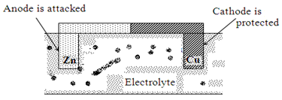
Diagram

Mechanism
Zinc metal forms anode (higher in series) and undergoes oxidation and corrosion occurs.
Copper metal acts as cathode (lower in series) and remains unaffected.
In acidic solution, corrosion occurs by hydrogen evolution process.
In neutral or alkaline solution, oxygen absorption occurs.
Thus, corrosion occurs at anode metal; while cathodic part is protected from the attack.
Rate of corrosion
Larger the difference in their position in electrochemical series, greater will be the extent of corrosion.
Rate of corrosion will be high if area of cathode is large and anode is small.
(b) Pitting corrosion
Pitting corrosion is localized attack, resulting in formation of pit around which metal is un-attacked.
It is due to breakdown or cracking of protective film on a metal at specific points.
This gives the formation of small anodic and large cathodic areas.
Example
Metals having passive character show pitting under all conditions, leads to destruction of passivity.
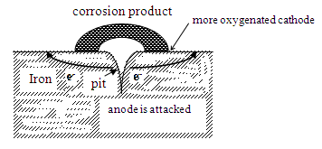
For example, stainless steel and aluminium show pitting in chloride solution.
Diagram

Breakdown of protective film caused by,
(i) Surface roughness and scratches
(ii) Local strain due to non-uniform stress and sliding under load
(iii) Turbulent flow of solution and by chemical attack.
Rate of corrosion
Presence of impurities like sand, dust and scale on metal also lead to pitting.
Because of different oxygen, small part under impurity becomes anode and surrounding large parts become cathode and intense corrosion starts below the impurity.
Once a small pit is formed, the rate of corrosion will be increased.
6
4. Discuss Concentration cell corrosion and Stress corrosion. (Jan 14, May 10, 15, 19)
(a) Concentration cell corrosion
It occurs when metal surface is exposed to an electrolyte of varying concentration or aeration.
Differential aeration corrosion
This occurs when one part of metal is exposed to different air concentration from other part.
Poor-oxygenated part act as anodic and get corroded.
This corrosion takes place in metals partly dipped in solutions and partly covered with dust and sand.
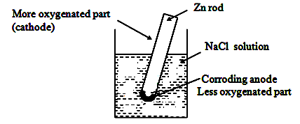
Example: Zinc metal partly immersed in solution of NaCl.
Diagram

Mechanism
Metal above liquid is exposed to higher oxygen and metal below liquid has less oxygen.
A concentration cell is set up and more oxygenated part acts as cathode and lesser one acts as anode.
Hence corrosion take place at anodic area and oxygen will take up electrons at cathodic area to form hydroxyl ions. Thus, the portion under water surface undergoes corrosion.
(b) Stress corrosion
Stress corrosion is the combined effect of static tensile stresses and corrosive environment on a metal.
Corrosive agents are specific and selective. For example, alkalis, nitrate solution and traces of ammonia for mild steel and acid chloride solution for stainless steel.
Example: In fabricated articles of alloys (like high-zinc brasses and nickel brasses).
Stresses caused by heavy working like rolling, drawing and insufficient annealing.
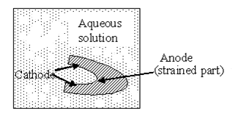
Diagram

Mechanism
Stress corrosion involves in localized corrosion, occurring along narrow paths. This forms anodic areas with respect to more cathodic areas at metal surface.
Presence of stress produces strain, which result in localized zones of higher electrode potentials.

Season cracking: Pure copper is immune, but presence of P and Si result in stress corrosion.
Caustic embrittlement: Occurs in mild steel exposed to alkaline solutions at high temperature and stresses.

7
5. Explain corrosion control by cathodic protection methods. (Jan 11, 14, 15, May 11, 12, 13, 15, 19)
Corrosion control by cathodic protection
Process of protection of parent metal from corrosion by forcing base metal to behave as cathode is known as cathodic protection. Two methods of cathodic protection are,
(a) Sacrificial anodic method
In this method, metallic structure to be protected is connected by a wire to a more anodic metal.
Example
Mg, Zn and their alloys.
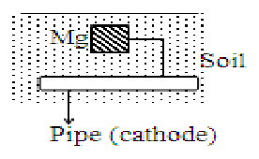
Diagram

As a result, all the corrosion is concentrated at this more active metal. The original structure becomes cathode and hence protected from corrosion.
More active metal used for this purpose is called sacrificial anode. When sacrificial anode is corroded, it is replaced by fresh one.
Applications
- Protection of buried pipelines and underground cables.
- Protection of water tanks, marine structure and ship-hulls.

(b) Impressed current cathodic protection
In this, an impressed current is applied in opposite direction to nullify corrosion current and convert corroding metal from anode to cathode.
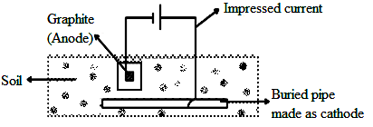
Diagram

Usually, impressed current is derived from a direct current source like battery or rectifier on a.c. line.
Anode is an insoluble metal like graphite, buried in soil or immersed in corroding medium and connected to the metallic structure to be protected.
The anode is in a backfill, composed of coke breeze so as to increase electrical contact with soil.
Applications
- Mainly applied for large structures of long term operations.
- For open water-box coolers, transmission line towers, marine piers and laid-up ships.

8
6. What are corrosion inhibitors? How do they act? (May 10, 14, Jan 11, 14)
Corrosion inhibitors
Inhibitors are organic or inorganic chemical substances. When added in small quantity to corrosive environment, it decreases corrosion rate by forming a protective layer either at anodic or cathodic area.

(a) Anodic inhibitors
They are salts which contain anions that form sparingly soluble compounds with ions of the metal.
Example: Compounds of chromates and tungstates.
These substances stifle corrosion reaction occurring at anode, by forming a sparingly soluble compound with a newly produced metal ion.
They are adsorbed on metal surface forming a protective film, thereby reducing the corrosion rate.
Drawback
When certain areas are left unprotected by depletion of inhibitor, then severe local attack can occur.

(b) Cathodic inhibitors
They are substances capable of reacting with cathode to form precipitates and its action depends on nature of metal and environment.
(i) In acidic solution: Main cathodic reaction is evolution of hydrogen,
Corrosion reduced by:
(a) Slowing diffusion of H⁺ ions. Example: amines
(b) Increasing overvoltage of hydrogen. Example: arsenic oxides
(ii) In neutral solution: Cathodic reaction is formation of hydroxyl ions.
Corrosion controlled by:
(a) Eliminating oxygen. Example: deaeration
(b) Reducing diffusion of oxygen. Example: Mg salts

(c) Vapour Phase Inhibitors
Having high pressures, they are transferred by volatilization to metal surface and wiped easily.
They are used in protection of machinery or equipment meant for shipment.
Example: Phenyl thiourea

9
7. Explain Galvanizing and Tinning process. (May 11, 12, 13, Jan 13, 15)
(a) Galvanizing
Application of zinc coating over iron surface to prevent rusting is called Galvanizing.
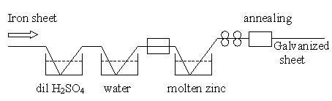
Diagram

Process
Iron article (sheet or pipe) is first cleaned by dilute sulphuric acid for 20 minutes at 90°C. This removes any scale, rust and impurities from the surface.
Article is then washed well and dried. It is then dipped in a bath of molten zinc maintained at 430°C. The bath surface is covered with ammonium chloride flux to prevent oxide formation.
Coated article is passed through a pair of rollers to remove excess of molten zinc and to obtain a thin uniform coating. It is then annealed at 650°C and finally cooled slowly.
Application
For protection of iron from corrosion in the form of sheets, wires, pipes, nails, bolts and screws.
Drawback
Galvanized utensils cannot be used for storing foodstuffs as it forms poisonous compounds.

(b) Tinning
Application of tin over copper, brass or steel is called Tinning.
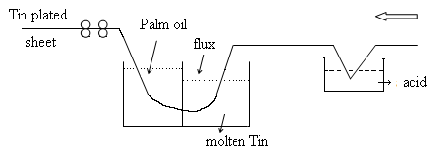
Diagram

Process
The base metal is first treated with dil. H₂SO₄ to remove any surface impurities. It is then passed through a bath of zinc chloride flux. The flux helps molten metal to adhere to the metal sheet.
The metal sheet then passes through a tank of molten tin kept at 235°C and passed through surface of a layer of palm oil. Palm oil protects hot tin-coated surface from immediate oxidation.
It is then passed through a pair of rollers to remove any excess of tin. This produces a thin film of uniform thickness on steel sheet.
Application
- It is used for coating steel, copper and brass sheets.
- Because of non-toxic nature, it is used for containers storing ghee, oils and packing food materials.

10
8. Discuss electroplating and its applications. (Nov 10, Jan 14, May 15)
Electroplating
Electroplating consists in depositing a thin layer of superior metal or alloy over inferior base metal.
This is done by passing direct current through electrolytic solution, containing metal ions to deposit.
Principle
Base metal to be plated is made as cathode and anode is coating metal itself. Both electrodes are immersed in electrolyte. When current passed, anode metal gets oxidized and deposited on cathode article.
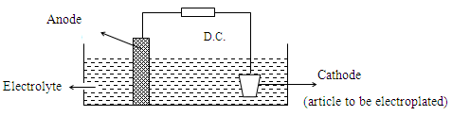
Diagram

Process
Article to be electroplated is first treated with organic solvent like acetone to remove oils and greases. It is then treated with dilute acids to remove any scales and oxides.
Cleaned article is then made cathode of an electrolytic cell. Anode is either coating metal itself or an inert material like graphite.
Electrolyte is a solution of a soluble salt of coating metal and is kept in an electroplating tank.
When direct current is passed, coating metal ions migrate to cathode and get deposited there.
Factors affecting Electroplating
Nature of metal, electrolyte concentration, current density, temperature, time and pH.
Application
(i) Gold, silver and copper used for decorative plating.
(ii) Iron and steel are protected from corrosion with copper, nickel and chromium.
- Improves appearance, hardness and surface properties.

11

